USER MANUAL – DOCTOR USPARK

LOGIN AND SETUP ACCOUNT:   
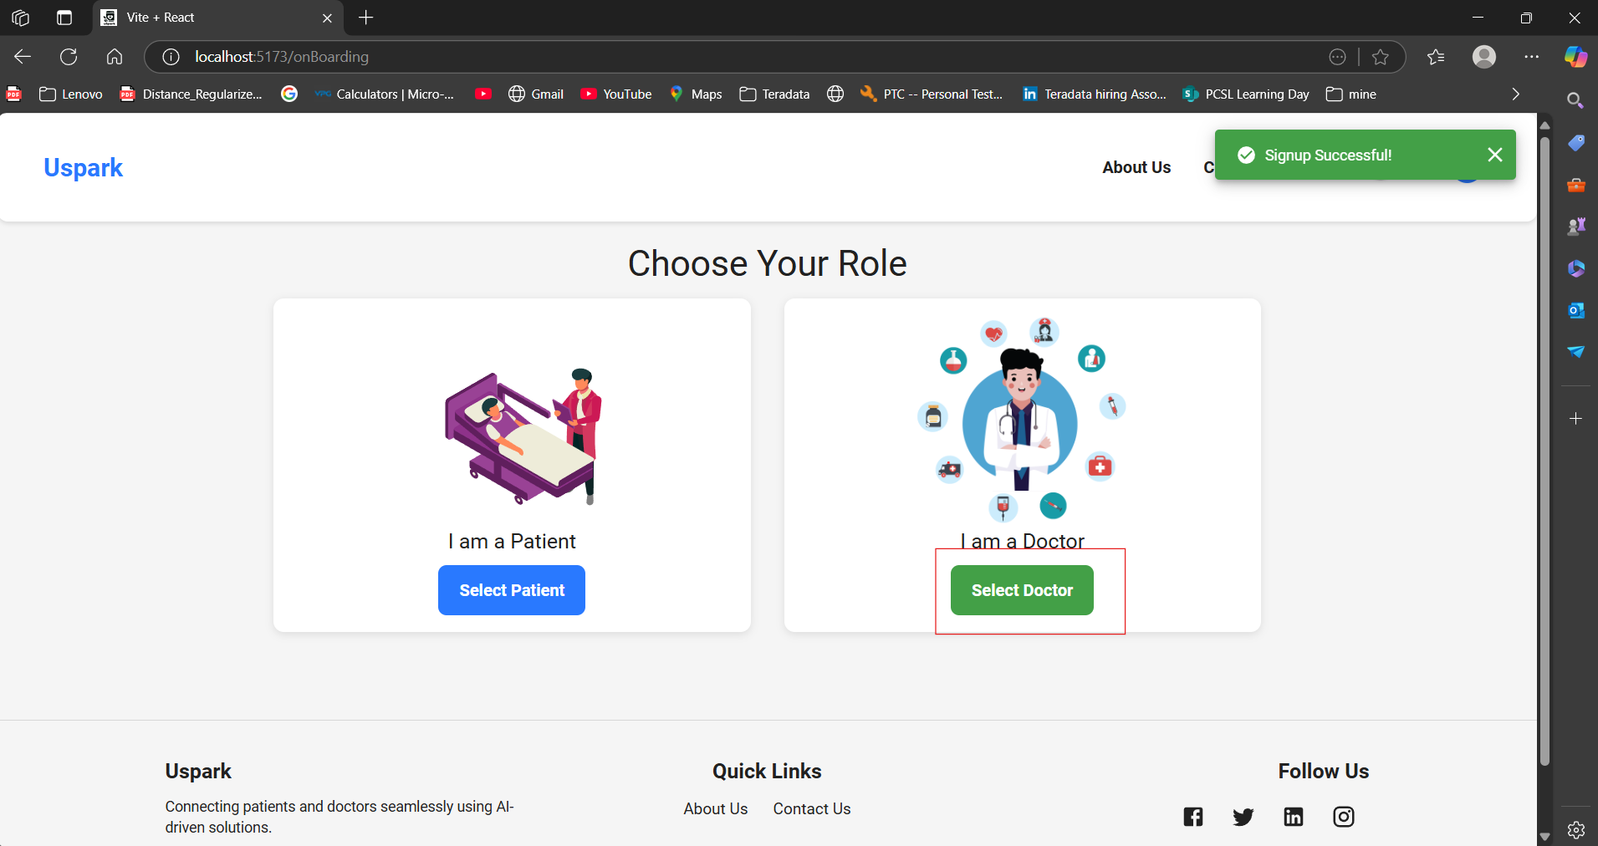

Once all the login details have been entered, you are directed to onboarding page where Select Doctor is to be selected to create a doctor profile.

ONBOARDING:

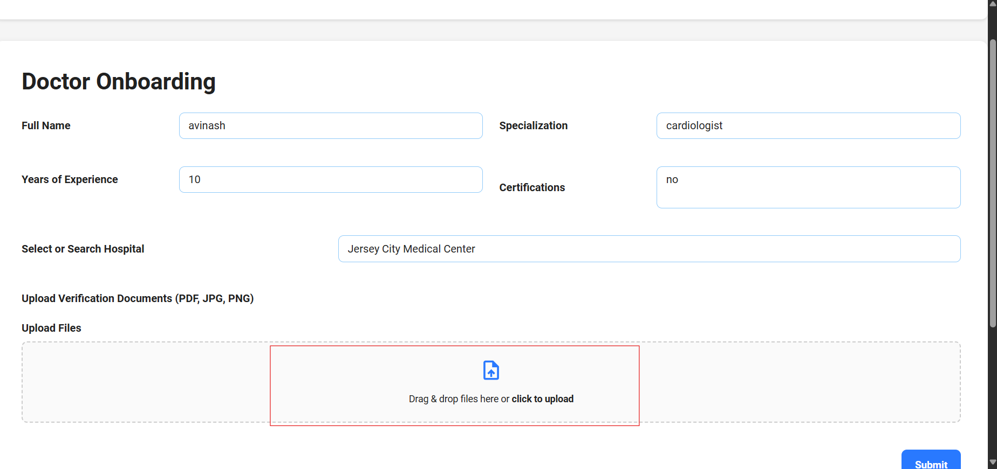

All the details for onboarding are to be filled and click on submit to onboard yourself as Doctor, click on upload to upload doctor for verification.

SUBMIT DOCUMENTS FOR VERIFICATION:

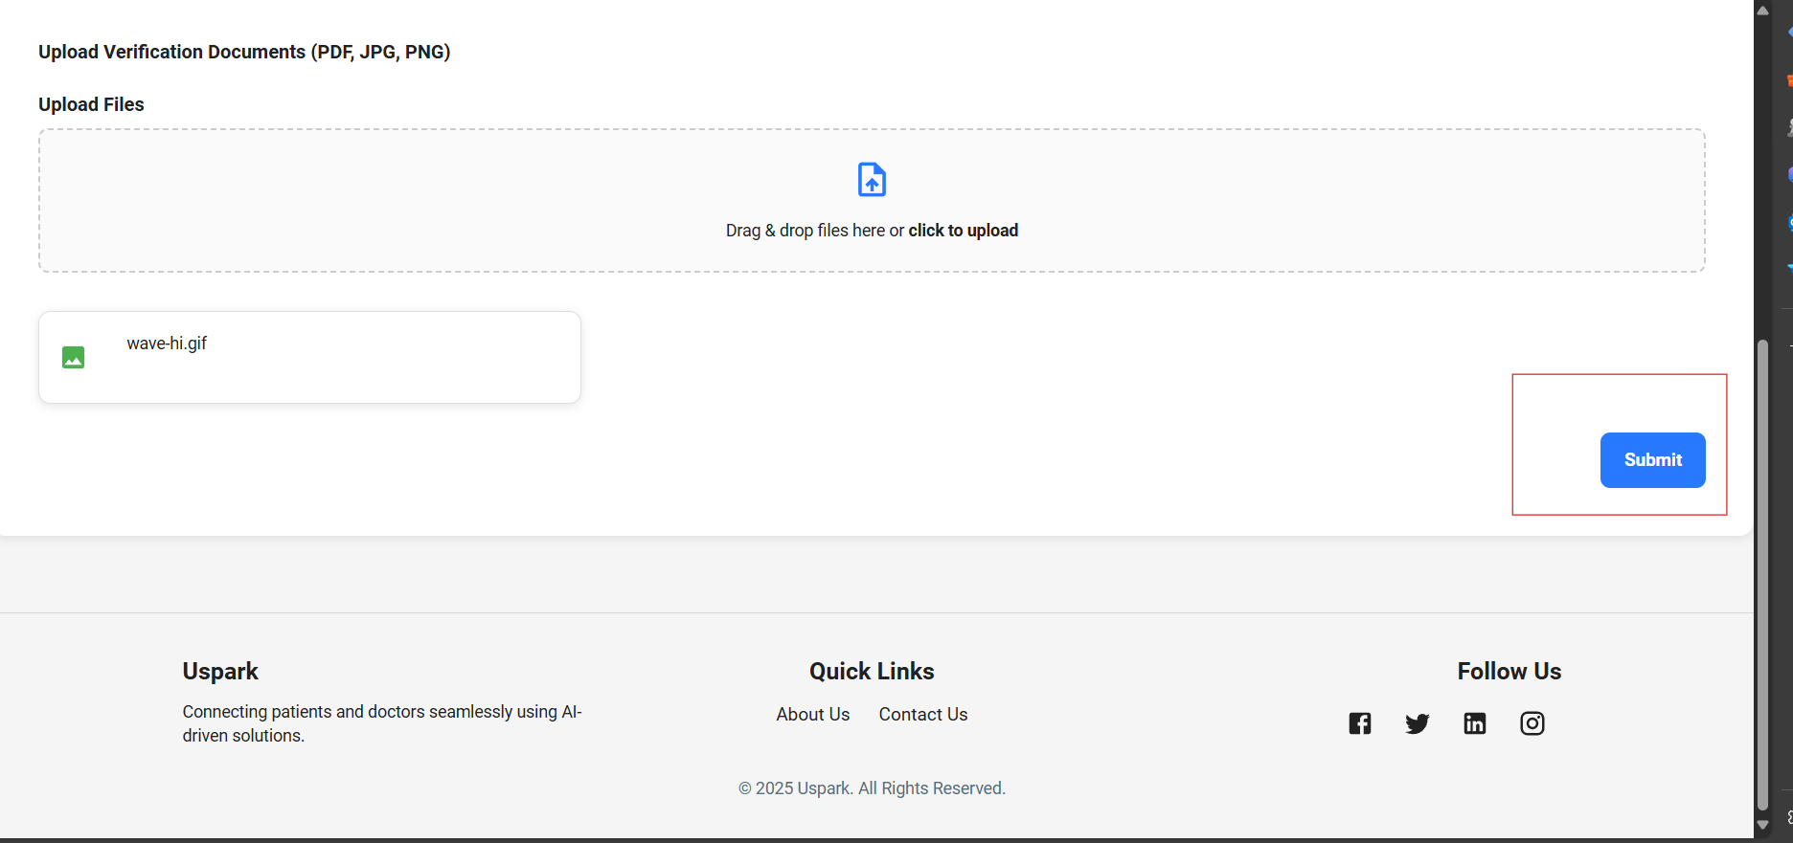

Click on submit-to-submit documents for verification, once details are verified then the doctor status changes to verified from pending.

PROFILE:

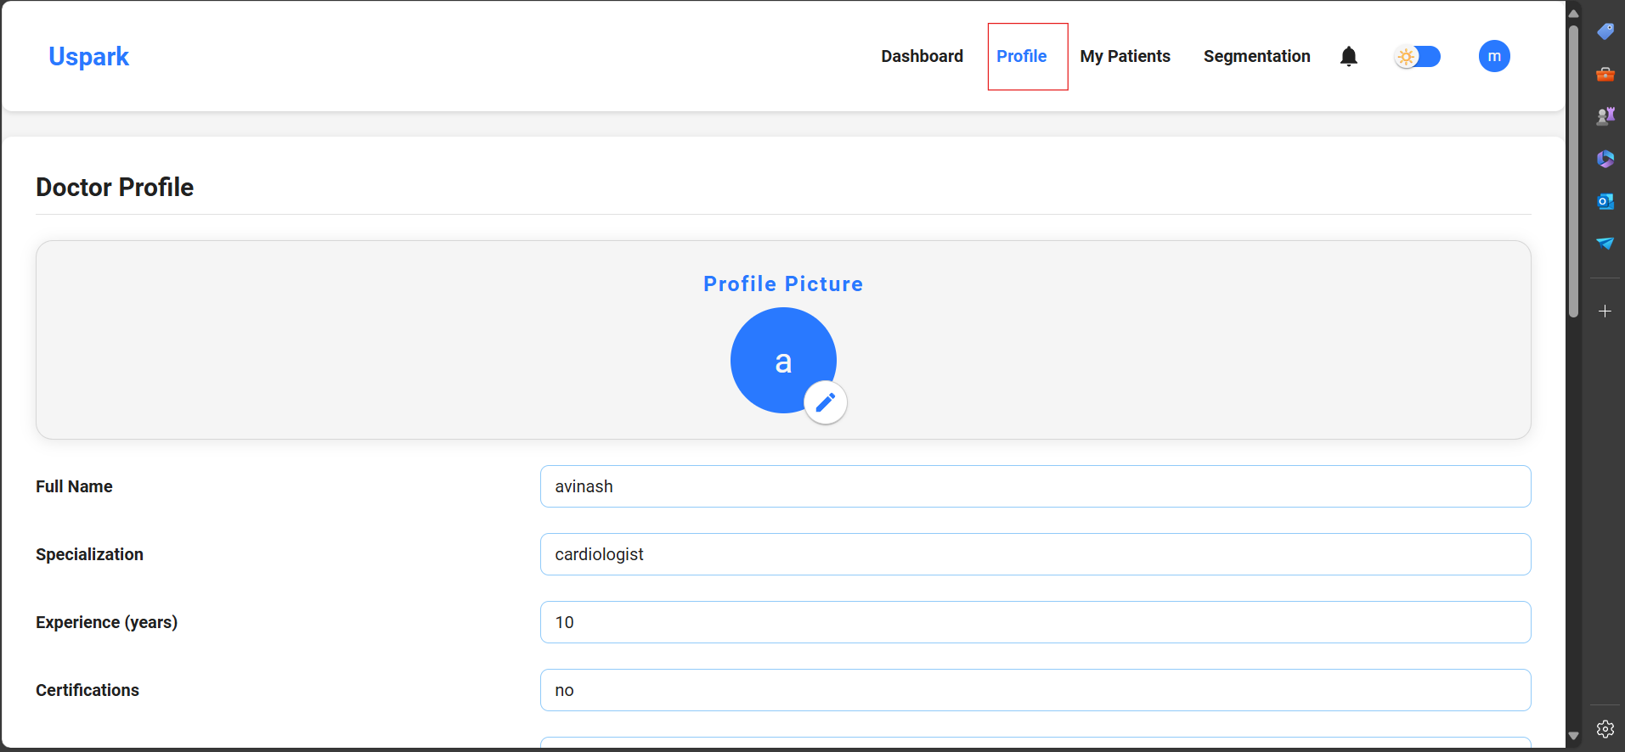

Click on the profile, to view the profile of the doctor.

ADD AVAILABILITY:

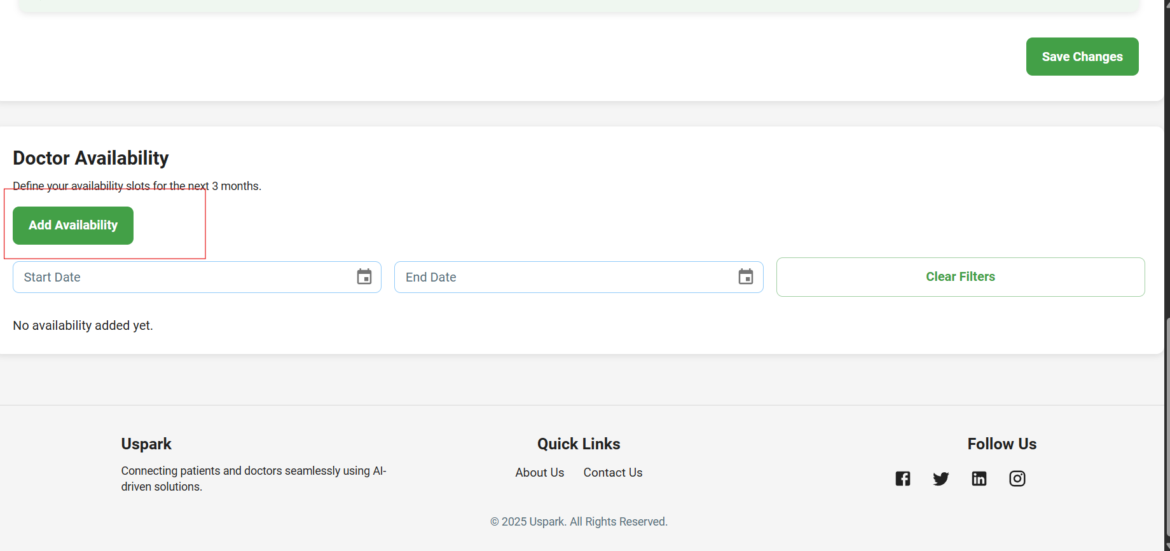

As a verified doctor add availability, by clicking on the add availability button.

CHOOSE APPOINTMENT MODE

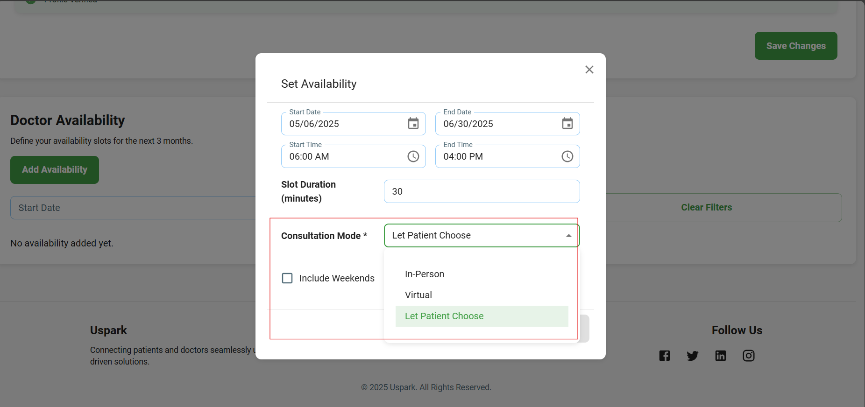  
you can select appointment mode as virtual, in person or let the patient choose, use the above filed for selecting that .

SAVE AVAILABILITY:

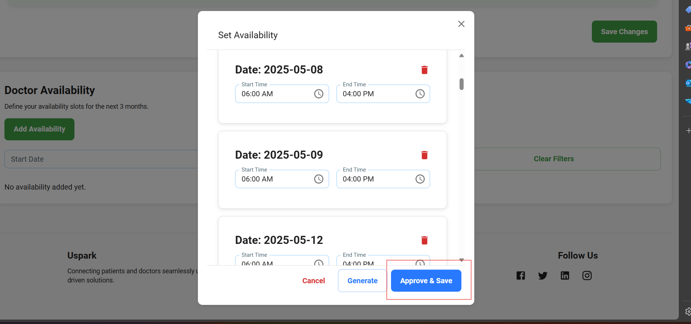

Click on approve and save to save the availability.

VIEW APPOITNEMNTS:

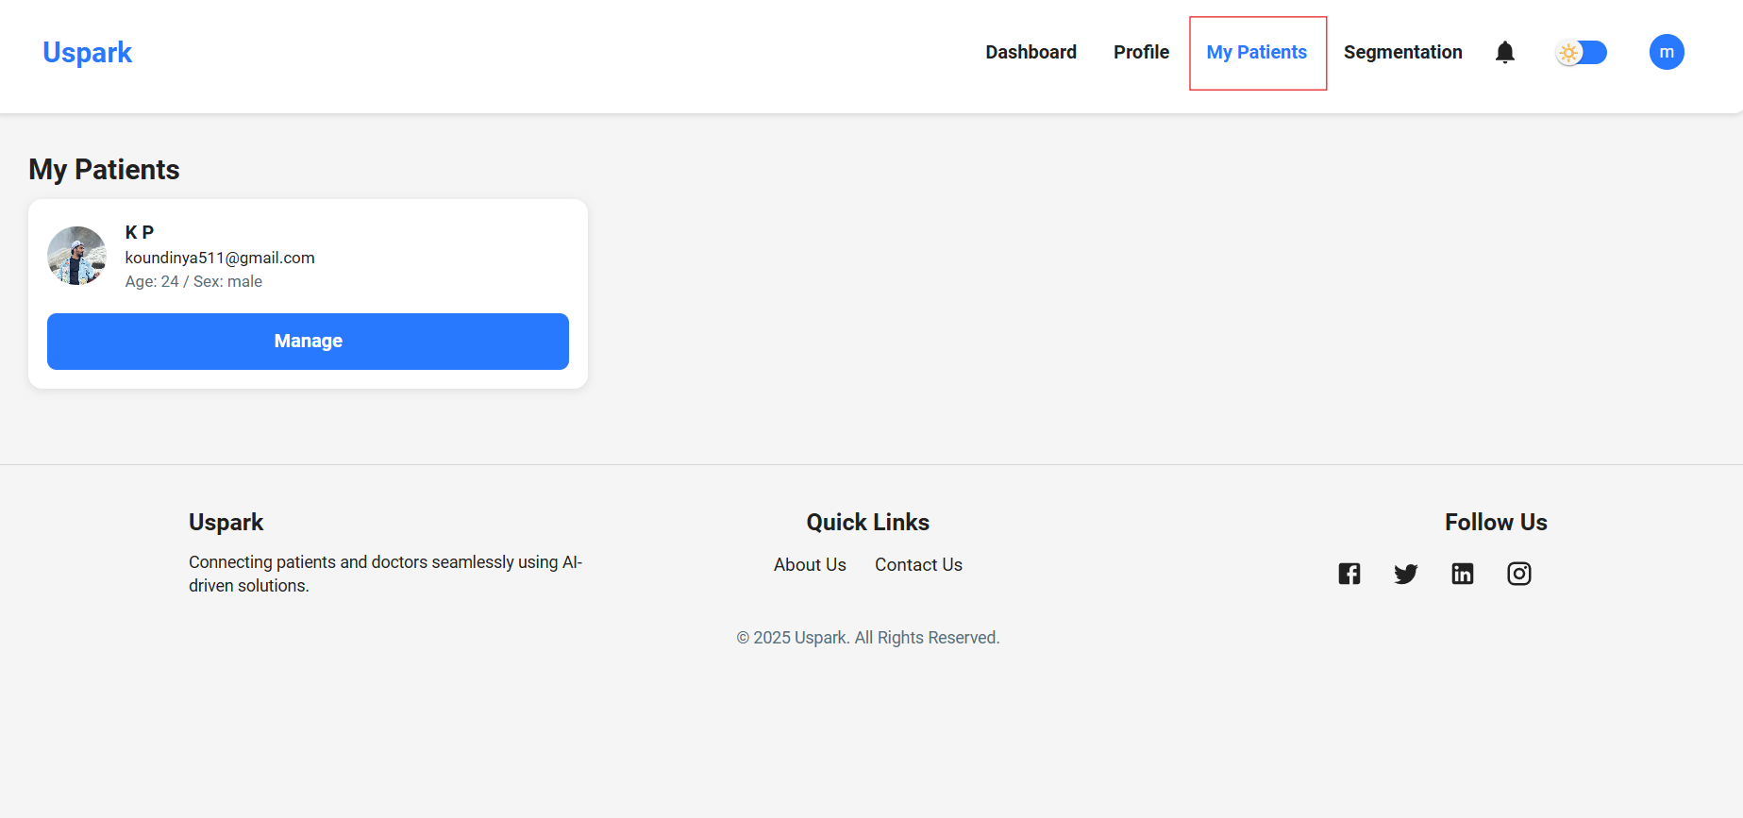

View the appointments by clicking on my patients button.

MANAGE AND VIEW PATIENTS PROFILE:

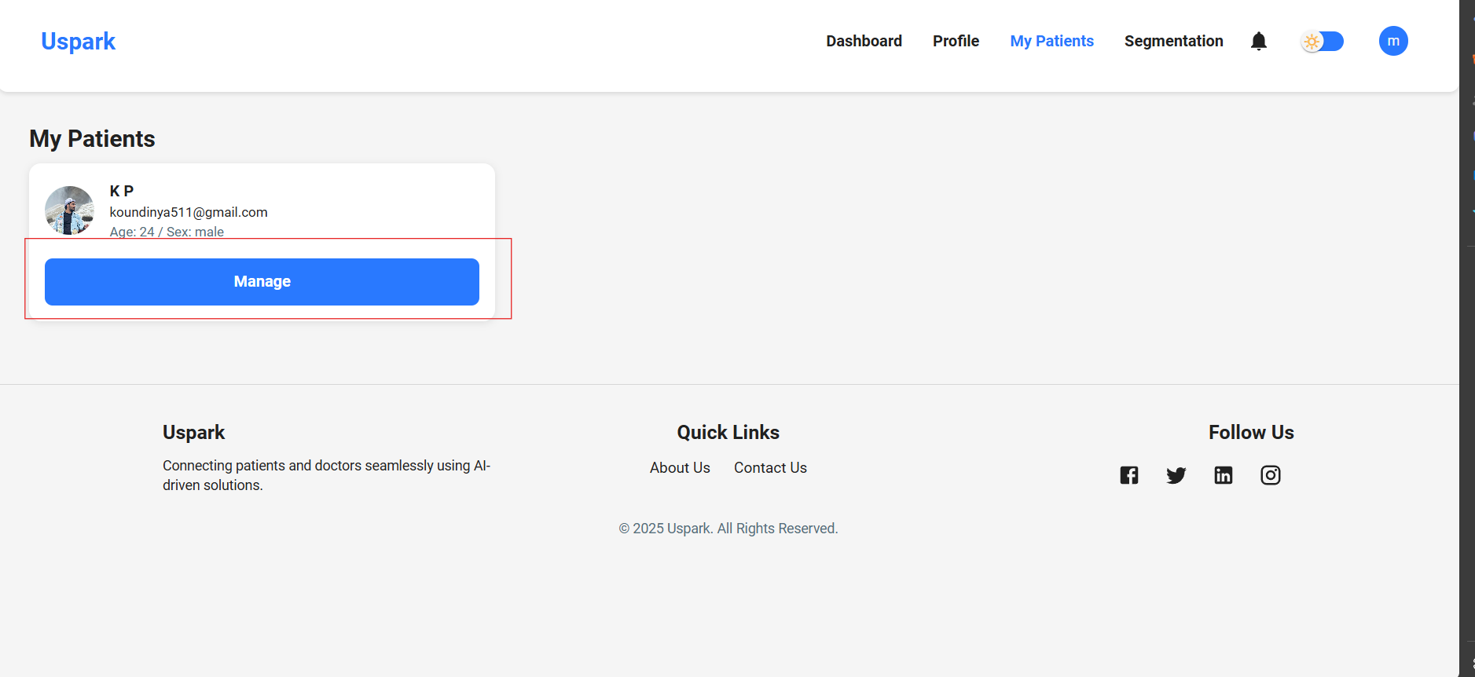

Click on the manage button to view the patient details.

USE ML ASSISTANT (USEG):

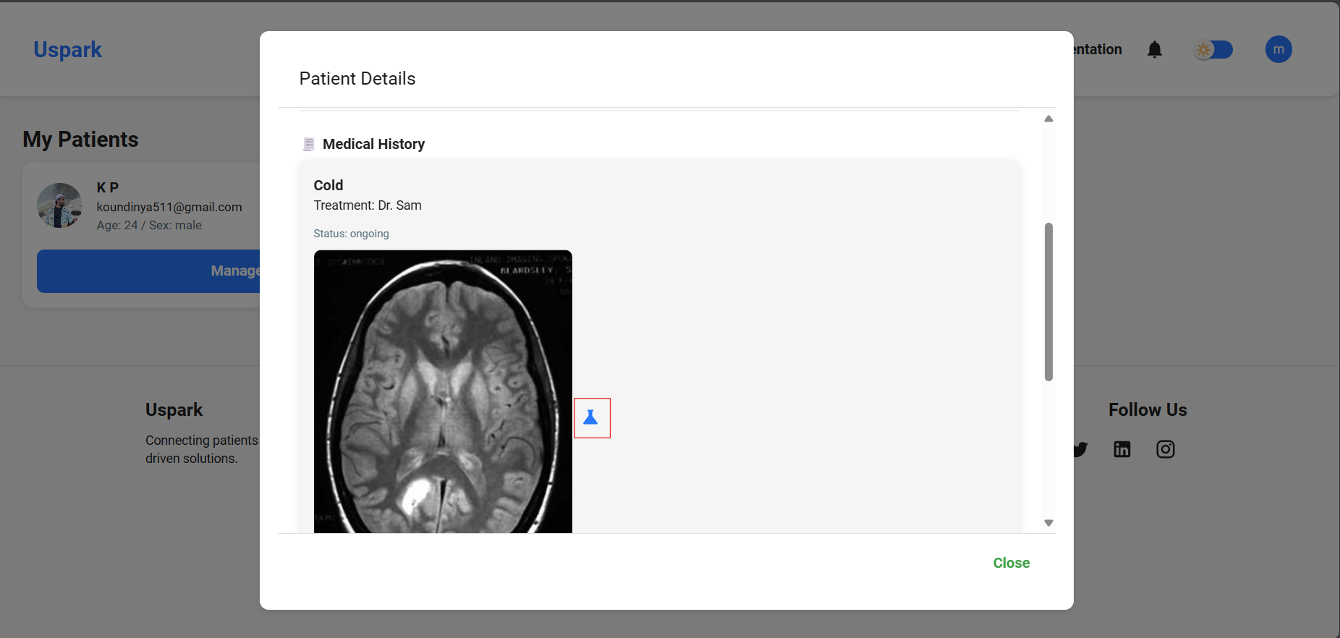

Click on the segmentation button the segment the images that belong to patient’s medical history.

VIEW THE RESULT:

